# TITLE

**HEALTH MONITORING SYSTEM**

**21IE3045 AND MCP-2**

By

**HARISH - 2110040001**

**S SAI LAKSHMAN GOUD - 2110040019 VISHWAS RALLAPALLI - 2110040040**

Under the guidance of

**MADHAVI**



**Department of Electronics and Communication Engineering, KL UNIVERSITY, Hyderabad**

**January, 2024**

An inventive approach to healthcare is exemplified by the health monitoring system scribed in this abstract, which uses real-time data to provide proactive and individualized patient treatment. This system offers timely insights into critical health metrics and integrates seamlessly into current healthcare frameworks, such as electronic health records. It seeks to improve patient outcomes and healthcare efficiency by utilizing cutting-edge technologies. With a brief synopsis of the system’s goals, reach, and importance, the abstract offers a peek at how it can affect contemporary medical procedures.

1. **INTRODUCTION 1**
2. **BENEFITS OF SYSTEM 2**
3. **ANALYSIS AND REPORTING 3**
4. **INTEGRATION WITH HEALTH PROVIDERS 4**
5. **RESULTS 5**
6. **CONCLUSION 6**

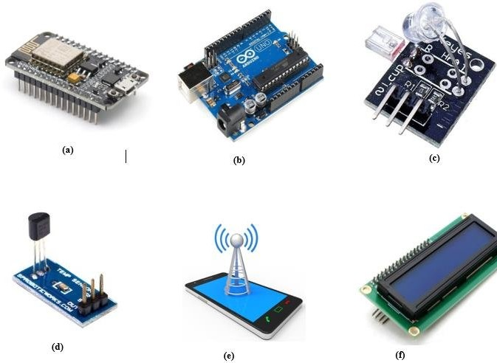

# INTRODUCTION

Discovering the transformative power of a health monitoring system, a comprehensive solution that empowers individuals to take control of their well-being. With advanced data collection methods, seamless integration with healthcare providers, and an array of benefits, this system is paving the way for the future of healthcare. Explore the components, analysis, and the exciting possibilities ahead.

Take a closer look at the key features and functionalities of the health monitoring system. From real-time data tracking to personalized health insights, this system provides a holistic approach to monitoring and improving well-being.

The health monitoring system provides real-time insights into patient well-being, dressing the changing needs of healthcare. This approach, which focuses on proactive treatment and personalized interventions, smoothly interacts with electronic health data and healthcare providers. It emphasizes technology developments to enhance the effectiveness and results of healthcare. This introduction provides an overview of the system’s goals, extent, and importance, laying the groundwork for a thorough investigation in the report that follows.

# BENEFITS OF SYSTEM

**Continuous Monitoring** Monitor your health around the clock for early detection and prevention of potential health issues. **Empowered Self-Care** Take charge of your well-

being with personalized health insights and actionable recommendations.

**Proactive Healthcare** Benefits from timely interventions and personalized care plans based on real-time data and analysis.

**Improved Communication** Facilitate effective communication and collaboration between individuals and healthcare providers for efficient and coordinated care.

**Early Health Problem Identification** Regular observation can aid in the early identification of health problems before they worsen, enabling prompt intervention and treatment. It makes proactive chronic illness management possible, which helps to avert complications.

**Remote Patient Observation** Frequent hospital visits can be minimized by using remote patient monitoring. Patients who are recovering from surgery, elderly patients, or those with chronic diseases can all benefit from remote monitoring.

**Studying Population Health** Medical research and population health studies can benefit from aggregated and anonymized data from health monitoring systems, which could lead to improvements in healthcare practices and legislation.

# ANALYSIS AND REPORTING

**Gathering and Combining Data** Accurately gather and combine data from multiple sources.

**Preprocessing and Data Cleaning** Eliminate outliers, standardize formats, and address missing data.

**Time-Based Analysis** Examine patterns and trends across time.

**Comparative Evaluation** Evaluate modifications by comparing metrics against benchmarks.

**Forecasting using Modelling** Make forecasts about future health outcomes using machine learning.

**Reporting** Make in-depth reports with custom visualisations.

**Practical Takeaways** Make suggestions for actions and modifications.

**Observance and Confidentiality** Make sure privacy laws and healthcare requirements are followed.

# INTEGRATION WITH HEALTH PROVIDERS

**Standards for Interoperability** Make sure that the systems of healthcare providers integrate seamlessly by utilising interoperability standards such as FHIR or HL7. Inte- gration of Electronic Health Records.

**Warnings and Announcements** Demonstrate how the system may improve re- response times by producing timely warnings for healthcare professionals based on important health occurrences.

**Supporting Clinical Decisions** Emphasise how clinical decision support is integrated and how it gives medical practitioners practical insights for diagnosis and treatment.

**Friendly Interfaces for Users** Provide healthcare practitioners with user interfaces that are simple to use and that facilitate quick access to patient data and customizable displays.

**Instruction and Assistance** Explain the training courses and continuing assistance that healthcare personnel receive to guarantee that the integrated system is used effectively.

**Flexibility and Scalability** Emphasise the system’s adaptability to changing healthcare practices and scalability to handle an increase in the number of users.

# RESULTS

**Metrics for Individual Health** Provide the results for every health parameter that is being tracked, highlighting any trends, variances, or correlations that were found during the investigation.

**Comparative and Temporal Analysis** Display any time patterns, compare your results to benchmarks, and talk about the clinical implications.

**Using predictive modeling, if appropriate** Talk about the outputs of predictive models and how well they forecast future health outcomes.

**Using risk stratification** Provides an overview of how people are categorized accord- ing to their health risk, emphasizing tactics for focused interventions.

**Compliance and Privacy** Stress again how the analysis protects data confidentially by abiding by privacy rules and laws.

**Restrictions and Upcoming Courses** Recognise the limitations of the study and offer possible directions for further investigation or system upgrades.

# CONCLUSION

In conclusion, it should be noted that the health monitoring system has significantly improved patient care. Important discoveries highlight its clinical relevance and show that it can be successfully integrated with healthcare professionals. Early identification and tailored therapies are beneficial to patients. Users give the technology positive comments because it improves workflow efficiency in the healthcare industry. Standards for privacy and compliance are given priority, with admitted shortcomings opening the door for further advancements. The system’s ability to improve healthcare outcomes and make new improvements seems optimistic as we move forward.